Crypt-Arithmetic Problem

Aim
To implement a Crypt-Arithmetic problem using Python.
Objective
To assign unique digits to different letters so that the given arithmetic equation is mathematically correct.
Algorithm
- Get the crypt-arithmetic puzzle from the user.
- Identify all unique letters in the puzzle.
- Assign different digits from 0 to 9 to each letter.
- Ensure that the first letter of each word is not zero.
- Substitute the assigned digits into the words.
- Check whether the arithmetic equation is correct.
- Display the valid solution.
Flowchart
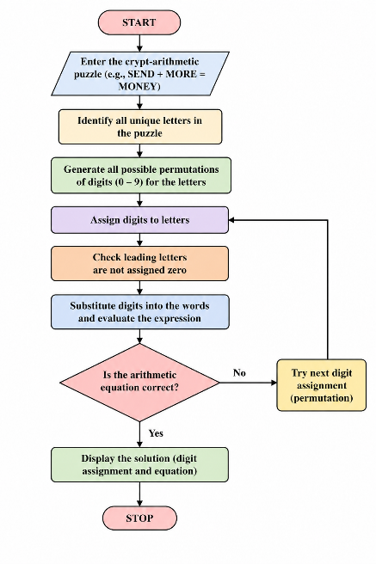

Python code
from itertools import permutations

def solve_cryptarithm(word1, word2, result):
letters = set(word1 + word2 + result)

if len(letters) > 10:
print("More than 10 unique letters are not allowed.")
return

letters = list(letters)

for digits in permutations(range(10), len(letters)):
mapping = dict(zip(letters, digits))

if mapping[word1[0]] == 0 or mapping[word2[0]] == 0 or mapping[result[0]] == 0:
continue

def convert(word):
return int(''.join(str(mapping[ch]) for ch in word))

num1 = convert(word1)
num2 = convert(word2)
num_result = convert(result)

if num1 + num2 == num_result:
print("Solution Found:")
print(mapping)
print(num1, "+", num2, "=", num_result)
return

print("No solution found.")

word1 = input("Enter first word: ").upper()
word2 = input("Enter second word: ").upper()
result = input("Enter result word: ").upper()

solve_cryptarithm(word1, word2, result)

OUTPUT
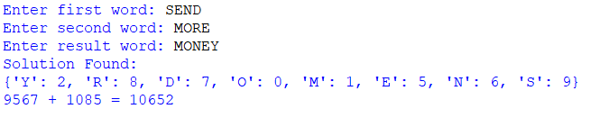
Result
The Crypt-Arithmetic problem was successfully solved by assigning unique digits to each letter.
Conclusion
The program successfully finds a valid digit assignment for the given Crypt-Arithmetic puzzle using permutation and constraint checking.

